**1.** **Login to Dokmee** 2

**2.** **Select Cabinet to go to the Search Form** 2

**3.** **On Search Form** 2

**4.** **On Search Result Page** 3

**a.** **Use the check box** 3

**b.** **Click Update button** 3

**c.** **Click Complete button** 4

**d.** **Click to file icon** 4

**5.** **Log Off the account to login other account** 5

1. **Login to Dokmee**

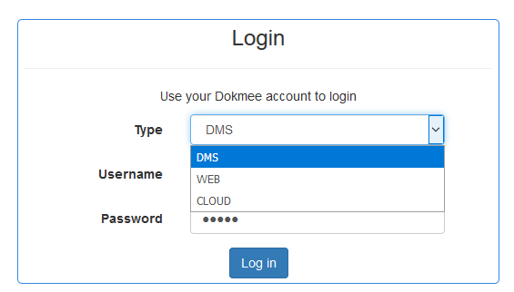

Select Login by Dokmee DMS, Web or Cloud in the Type Combobox and using the suitable account.

1. **Select Cabinet to go to the Search Form**

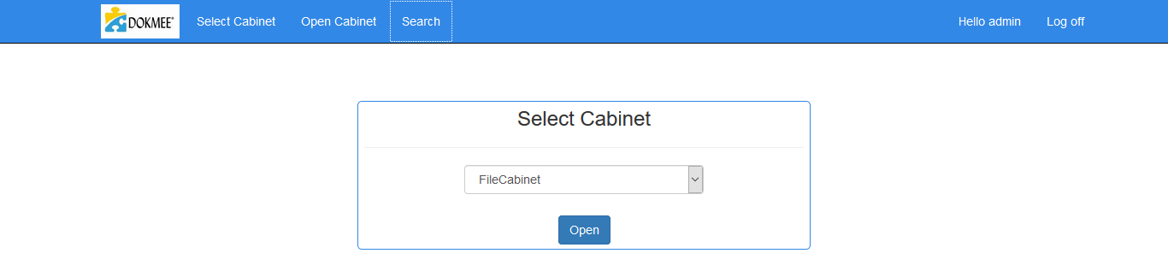

1. **On Search Form**

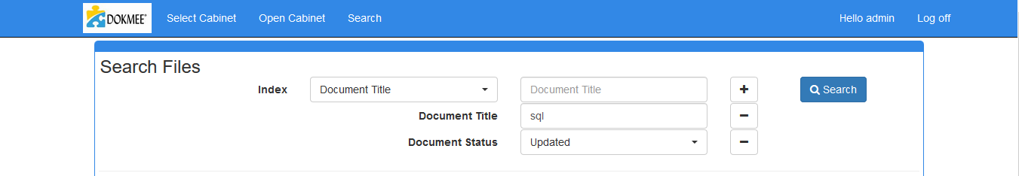

* Select the Index to search in the Index Combobox.
* Plus Icon: to add more search condition.
* Minus Icon: to remove this search condi.tion
* Search button: search data

1. **On Search Result Page**

Here is the result after searching with the search conditions above:

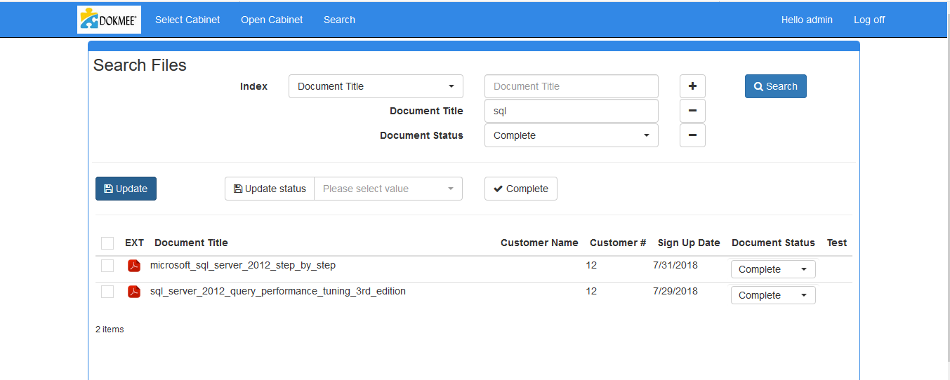

* 1. **Use the check box**

To select the file to update “Status” or complete the file:

* Select all or Unselect all files

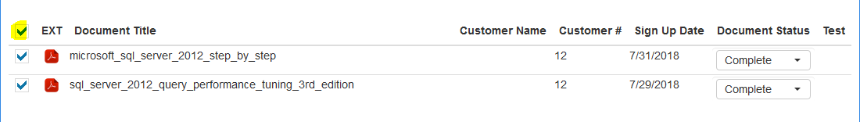

* Select one file

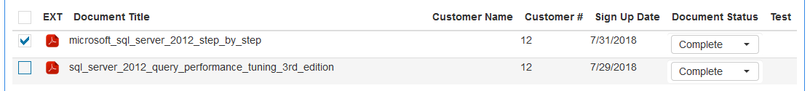

* 1. **Click Update button**

Update Status the selected files

* Select the files and select the new status:

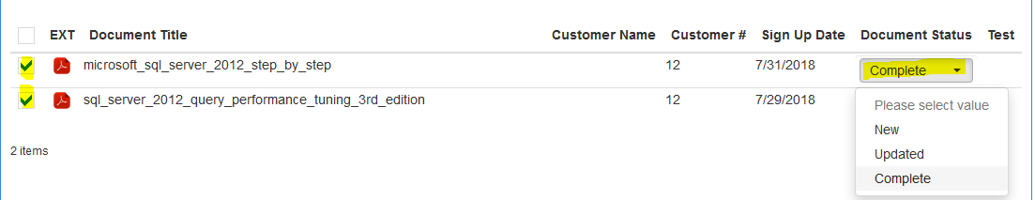

* Click Update Button to update the file status:

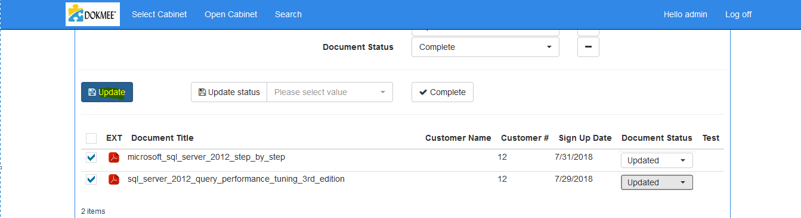

* Another simple action to apply the status to all of selected files:
  + Tick on checkbox to select the file.



* + Select the status:

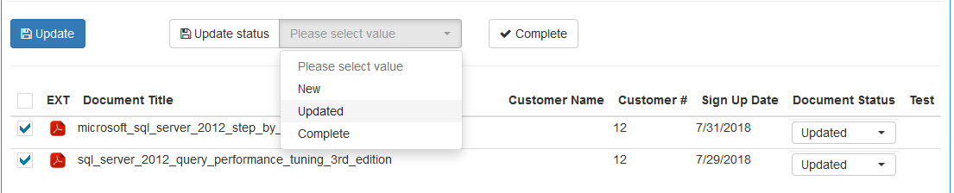

* + After that click Update Status button to apply this status to the selected files.



* 1. **Click Complete button**

Update Status to Complete all of the selected files and move to Temp folder

* Select the file is the same with Update file status.
* Click Complete button to move file



* 1. **Click to file icon**

Click the icon to open the file in the new tab

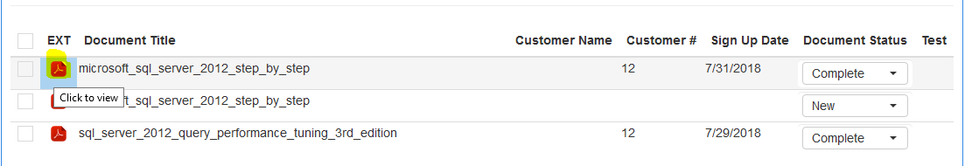

Here is the file content

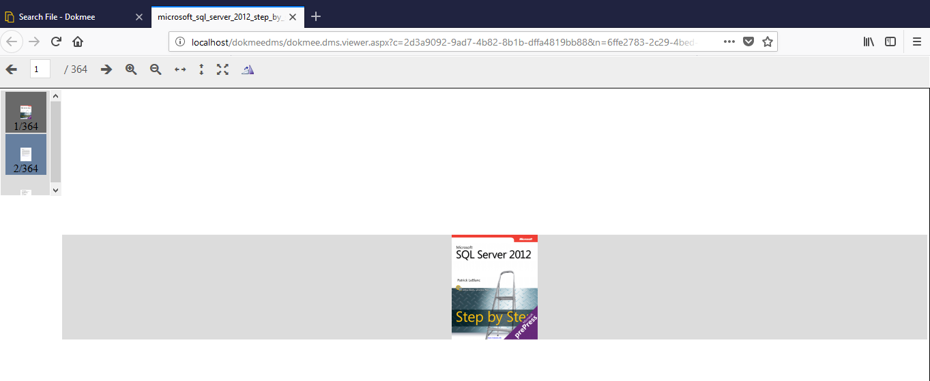

1. **Log Off the account to login other account**

